Dandelion Initial Idea - Napkin workflow
devin.g.ardalan@gmail.com

Dandelion Mechanics
Ideas to Incorporate and Study
Idea Shift: Right Before Ticketing
Talent Groupings
Talent Client Acquisition
Niche down on one type of service
Next Step
Cross Validate Work
Need own token — Equity in the marketplace
References
Reviews

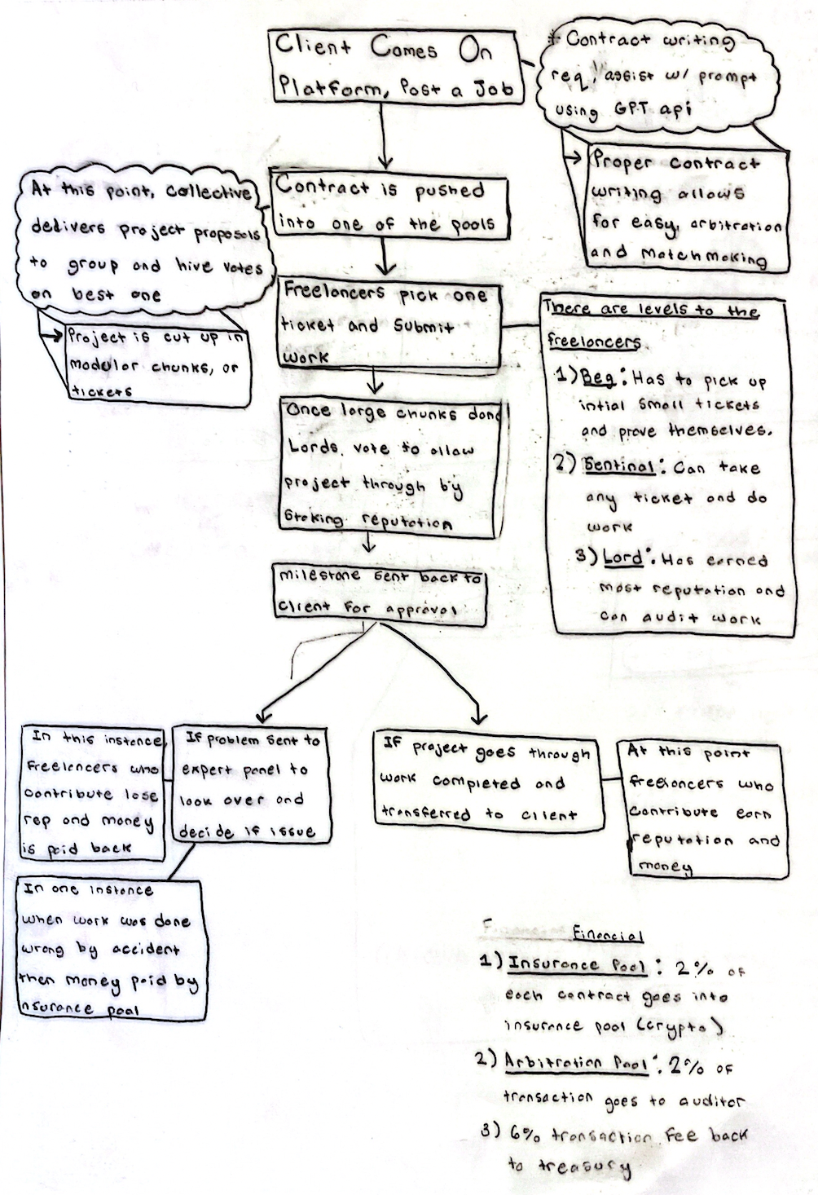

Dandelion Mechanics
Dandelion is a decentralized freelance marketplace that delivers high quality work without ever having to do a single interview.

We need to incorporate agile (actually instead of agile, scrum) into the workflow, it will make it a lot easier to develop the system based on the existing one. Here is a Reading List of initial sources we should look at.

Key things before we actually start working on this: How do we plan to organize our information on this document or will we need multiple documents?
- I think we should write out step by step and block together key phases. This will allow us to develop a more detailed approach to understanding each phase. Right now we get the overall picture for the most part but we do need to analyze how these things could blow up.
    - Contract/ Prompt creation
    - Project segmentation
    - Project execution
    - Project accept/ don’t accept
    - Project arbitration
- What are we trying to understand and how will that get us to the next phase? Once we understand the right information we will conduct human experiments to see if it actually plays out the way we think it will—thus, we will need to design and execute these experiments.

Ideas to Incorporate and Study
- Agile
- Skilled based matchmaking
- Reputation systems
- DAOs
- Work collectives (Raid Guild/ Vector Dao)
- Talent pools (Check out this LSE article)

Idea Shift: Right Before Ticketing
- Bigger projects, client puts out contract
- Then lords put out RFP — How they are doing project, KPIs, and Team
  - Idea is to lessen the risk the talent is taking (spending 20hrs & no pay)
- Then with the help of an expert (panel), the client decides on what team is the best

Talent Groupings
- People who audit can interview each other and that is all they do (audit shit)
- Also a talent collective for project managers
- The rest are worker bees

Talent Client Acquisition
Client UVP: We have exquisite talent, high quality work, no risk/no pay before approval.
Talent UVP: We have exquisite clientele.

Niche down on one type of service
Hot demand: ML
Low supply of high quality ML talent.

GitHub Community (OpenSource Community for Integrations)

Next Step
- Learn scrum and adapt to the quality evaluation system
  - Speak with Kathy Takayama and anyone we know in operations (Before we talk to these people, lets identify key questions)
- Develop a reputation system and skilled based matchmaking

Cross Validate Work
Econ people who do game theory
Computer science theory

Need own token — Equity in the marketplace
- What are the check and balance on the expert just trying to game the system

References
- Handbook Raid Guild. (n.d.). Proposal Types. Retrieved from https://handbook.raidguild.org/docs/proposal-types
- Ties.Network. (n.d.). Ties.Network Whitepaper. Retrieved from https://www.allcryptowhitepapers.com/ties-network-whitepaper/
- Garay, J. A., Kiayias, A., & Leonardos, N. (2016). The Bitcoin backbone protocol with chains of variable difficulty. Retrieved from https://eprint.iacr.org/2016/464.pdf
- Chen, R. (2016). Trustless Intermediation in Blockchain-Based Decentralized Service Marketplaces (Master's thesis). Retrieved from https://robinchen95.com/documents/Refer/22-Trustless%20intermediation%20in%20blockchain-based%20decentralized%20service%20marketplaces.pdf

Reviews
- Lai, F., Deng, J., Chen, X., Luo, J., & Feng, Y. (2009). A Trust Model Based on Reputation and Quality of Service for Web Services. In 2009 International Conference on Computational Intelligence and Security (pp. 470-474). IEEE. Retrieved from https://ieeexplore.ieee.org/stamp/stamp.jsp?arnumber=5207651&casa_token=oolScKi1Tg0AAAAA:8VtY9eTQpPyKLVvqGj-g2Z7CpPjRALhIM3zn2-eEzmM4MLCZP5lcH6X7stvl8QVJYU2Zn0i6Zw&tag=1

– One idea is that potential lords can KYC to attain their status. Therefore, they have authentic identities.

